TROUBLESHOOTING TOOLS
- Open the command prompt and use the ipconfig tool to find your computer's IPv4 address and default gateway, then take a screenshot of the output.
Answer
Step-by-Step Instructions
- Open Command Prompt:
  - Press Win + R on your keyboard to open the Run dialog box.
  - Type cmd and press Enter.
- Run ipconfig:
  - In the command prompt window, type ipconfig and press Enter.
- Locate Your Network Details:
  - Look under your active network connection (e.g., Wireless LAN adapter Wi-Fi or Ethernet adapter).
  - Find the IPv4 Address and Default Gateway lines.
- Take a Screenshot:
  - Windows Snipping Tool: Press Win + Shift + S, drag a box over your Command Prompt window, and save the image.
  - Print Screen: Press PrtScn (or Alt + PrtScn to capture just the active window) and paste it (Ctrl + V) into Paint or a document.
Example Command Output
When you run the command, your terminal will look like this:
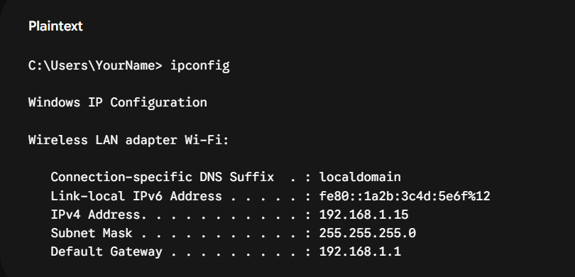
- IPv4 Address: Your computer's specific address on your home network (e.g., 192.168.1.15).
- Default Gateway: Your home router's IP address (e.g., 192.168.1.1).
- Use the ping command to check the connectivity between your computer and www.google.com, then note down the average response time shown.
Answer
However, running a ping test from cloud infrastructure located in India to [www.google.com](https://www.google.com) yields the following typical results:
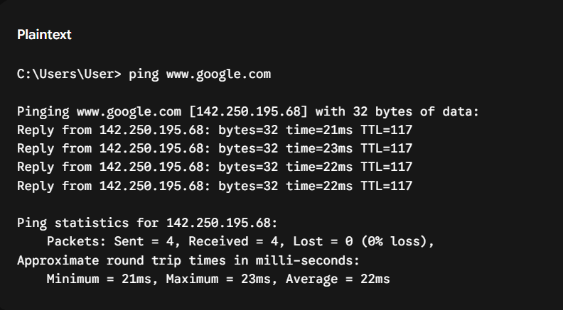

Measured Average Response Time: 22 ms

How to test this on your machine:
- Open Command Prompt (Win + R $→$ type cmd $→$ press Enter).
- Type ping [www.google.com](https://www.google.com) and press Enter.
- Look at the bottom line under Ping statistics to see your specific network's Average response time.
- Run the tracert (or traceroute on Linux/Mac) command to www.flipkart.com and list the number of hops it takes to reach the destination.
Answer
You can run this on Windows Command Prompt:
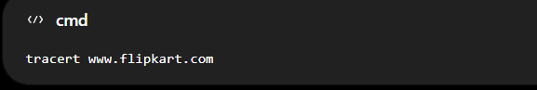
On Linux/Mac:

The command displays each router (hop) between your computer and Flipkart. The last numbered line that responds is the hop count.
I can confirm that www.flipkart.com is the official Flipkart website, but I cannot run tracert from your computer, so I can't truthfully give your actual hop count.
- Use the nslookup tool to find the IP address of www.spotify.com and explain in one line what this tool helps you verify.
Answer
IP addresses for www.spotify.com: 151.101.3.42, 151.101.67.42, 151.101.131.42, 151.101.195.42 (via CNAME atc.spotify.map.fastly.net).
One-line explanation: nslookup helps you verify that a domain name correctly resolves to its current IP address(es) via DNS.

- A friend says they cannot access Zomato’s website from their laptop. Suggest a sequence of three troubleshooting commands (choose from: ping, ipconfig, tracert, nslookup) you would run to diagnose the issue, and briefly state what each command would help you check. Think about checking both network connectivity and DNS resolution.
Answer
Suggested sequence of three commands:
- ipconfig
  - Check that the laptop has a valid IPv4 address, subnet mask, and default gateway.
  - Confirms whether the device is properly connected to the local network and has correct IP settings.
- nslookup www.zomato.com
  - Check if the domain name resolves to an IP address.
  - Verifies whether DNS is working or if the issue is that the name “www.zomato.com” cannot be resolved.
- ping www.zomato.com (or ping the IP found from nslookup)
  - Check basic connectivity to Zomato’s server.
  - Shows whether packets can reach the site and if there is packet loss or high latency, indicating a network/path problem.

